NEW BEDFORD HOMELESS SERVICE PROVIDER NETWORK (HSPN)
Membership Agreement.2024

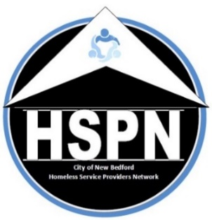
The City of New Bedford coordinates a comprehensive response to homelessness using a “Continuum of Care” (CoC) approach through its Homeless Service Provider Network (HSPN).

The HSPN is a broad community-based coalition of homeless providers, allied resources and community partners reflecting the diversity of the city and regularly meeting to strategically address the complexity of homelessness and make sure individuals and families have access to housing that is appropriate, sustainable safe, decent and affordable. It is committed to the concept that each person is entitled to live in dignity and is focused on the elimination of homelessness in New Bedford.

The HSPN advocates on behalf of individuals and families experiencing homelessness to improve access to housing and housing stability. In so doing it strives to:
- improve the availability of housing and supportive resources,
- competitively seek and secure funding for shelter, housing and supports,
- maintain robust data through a homelessness management information system (HMIS),
- evaluate and modify systems and practices to meet complex and changing needs within the continuum and beyond. All of this is done to build empowerment strategies that lift individuals and families out of homelessness and reintegrate them through a compassionate CoC.

This signed pledge of commitment to participate in the HSPN and its acceptance by the HSPN Executive Board serves as the basis of membership in the HSPN.

Active membership allows member organizations and those with lived experience a voice in the decision-making progress for issues brought before the HSPN including, but not limited to, the identification of homeless needs and the prioritization of projects for the annual Continuum of Care application. Active membership also allows access to federal homelessness funds from the U.S. Department of Housing and Urban Development administered by the City of New Bedford’s Office of Housing & Community Development (OHCD).

The HSPN meets the third Thursday of every month either at the OHCD’s offices located on the second floor of the Anthony S. Catojo Building (Art Museum) at 608 Pleasant Street in downtown New Bedford, via ZOOM or as a hybrid of both.

All are welcome to attend; all are encouraged to join.

Please print agency/org/indiv name:

Executive Director/CEO Name:

Address: City:

State/Zip:

Contact Name: Phone:

Contact Email:

As a member of the Homeless Services Provider Network the member agrees to:
- Abide by the HSPN Code of Conduct,
- Support all HSPN members in their efforts to provide housing, resources and services to those experiencing homelessness,
- Share resources and ideas for potential speakers and relevant topics for HSPN meetings.
www.nbhspn.com

All HSPN non-profit member organizations are eligible to apply for any funds that may become available; final eligibility depends on satisfactorily meeting the required conditions of any funding offered.

Signature: _____________________________________________Date: 2/14/2024

Please Email Completed Forms to: Jennifer.Clarke@newbedford-ma.gov

